(ADJUSTED TRAIL BALANCE & FINANCIAL STATEMENTS)
Practice Question
XYZ Inc., provides employment consulting services. The company adjusts its accounts monthly but performs closing entries annually on December 31. The unadjusted trail balance is as follows:
XYZ
UNADJUSTED TRAIL BALANCE
AS ON 31-12-2011
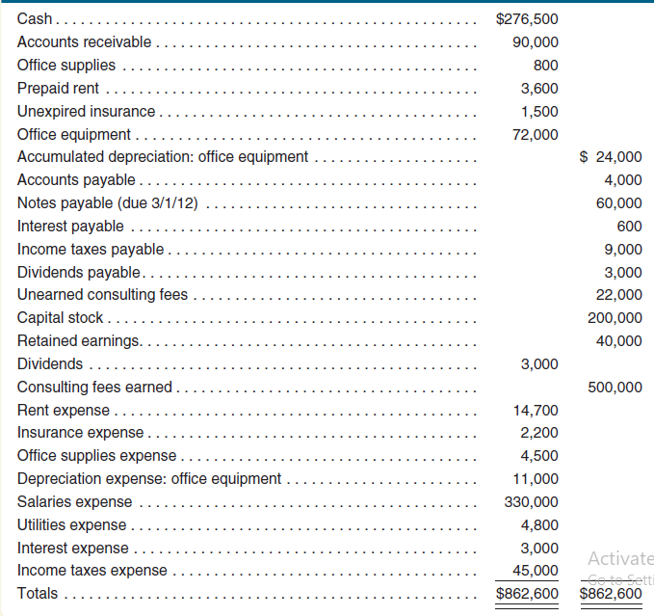
THE FOLLOWING ADJUSTEMENTS ARE REQUIRED AT YEAR END:
(1) Accrued consulting fee:
It means income due but not received as yet till the reporting date

Accrued but unrecorded consulting fees earned total $20,000 at December 31, 2011.
Debit: Accounts Receivable 20000
Credit: Consulting Fee Earned 20000

(2) Unearned (consulting fee):
It means fee was received in advance but we have to give services to the other party.

The company determined that $10,000 of previously unearned consulting services fees had been earned at December 31, 2011.
Debit: UNEARNED CONSULTING FEE 10000
Credit: CONSULTING FEE EARNED 10000

(3) Office supplies (Current asset)
These are current assets. As we use them we need to expense them.

Office supplies on hand at December 31 total $200 (800 – 200) 600
Debit: OFFICE SUPPLIES EXPENSE 600
Credit: OFFICE SUPPLIES 600

(4) Equipment (Non-Current Asset) & depreciation)
Depreciation needs to be recorded on non-current assets at each year end

The company purchased all of its equipment when it first began business. At that time, the estimated useful life of the equipment was 5 years (60 months).
72000/60 = 1200 PER MONTH X 12 MONTH = 14400
Debit: DEPRECIATION EXPENSE 14400
Credit: ACCUMULATED DEPRECIATION 14400

(5) Prepaid rent expense
It means rent paid in advance but benefit yet to be received

The company prepaid its ten-month rent agreement on June 1, 2011.
3600/10 = 360 X 7 MONTHS= 2520
Debit: RENT EXPENSE 2520
Credit: PREPAID RENT 2520

(6) Prepaid/Unexpired insurance expense
It means insurance paid in advance but benefit yet to be received
The company prepaid its ten-month insurance policy on December 1, 2011.
1500/10 = 150 X 1 MONTH = 150
Debit: INSURANCE EXPENSE 150
Credit: PREPAID / UNEXPIRED INSURANCE 150

(7) Accrued salaries expense
It means salaries due but not paid by the company

Accrued but unpaid salaries total $20,000 at December 31, 2011.
Debit: SALARIES EXPENSE 20000
Credit: SALARIES PAYABLE 20000

(8) Interest on loan
Interest on loan needs to be recorded at balance sheet date as an expense and liability

On September 1, 2011, the company borrowed $60,000 by signing a seven-month, 3 percent note payable. The entire amount, plus interest, is due on April 1, 2012.
60000 X 3% = `1800 PER ANNUM X 4/12 = 600
Debit INT EXPENSE 600
Credit: INT PAYABLE 600
(9) Taxation
Tax needs to be recorded at balance sheet date as an expense and liability

Company’s accounting firm estimates that income taxes expense for the entire year is $40,000. The unpaid portion of this amount is due early in 2012.

Debit: TAX EXPENSE 40000
Credit: TAX PAYABLE 40000

ADJUSTED TRAIL BALANCE

Accounts | Debit ($) | Credit ($)
Cash 276500 | 276500
Accounts receivable 90000 +20000 | 110000
Office supplies 800 -600 | 200
Prepaid rent 3600 -2520 | 1080
Unexpired insurance 1500 - 150 | 1350
Office equipment 72000 | 72000
Accumulated depreciation (office equipment) 24000+14400 |  | 38400
Accounts payable 4000 |  | 4000
Notes payable 60000 |  | 60000
Interest payable 600 +600 |  | 1200
Income tax payable 9000 +40000 |  | 49000
Dividend payable 3000 |  | 3000
Unearned consulting fees 22000 -10000 |  | 12000
Salaries payable 0 +20000 |  | 20000
Capital stock 200000 |  | 200000
Retained earnings 40000 |  | 40000
Dividends paid 3000 | 3000
Consulting fees earned 500000 +20000 +10000 |  | 530000
Rent expense 14700 + 2520 | 17220
Insurance expense 2200 +150 | 2350
Office supplies expense 4500 + 600 | 5100
Depreciation expense (office equipment) 11000 +14400 | 25400
Salaries expense 330000 +20000 | 350000
Utilities expense 4800 | 4800
Interest expense 3000 +600 | 3600
Income tax expense 45000 +40000 | 85000
Total | 957600 | 957600

Income Statement
 | ($)
Revenue:
Consulting fee earned / Revenue | 530000
Expenses:
Rent | (17220)
Insurance | (2350)
Office supplies expense | (5100)
Depreciation: office supplies | (25400)
Salaries | (350000)
Utilities | (4800)
Interest | (3600)
income before tax | 121530
Tax expense | (85000)
Net income (Income after tax) | 36530

Statement of Retained Earnings (Profit statement)

 | ($)
Opening balance retained earnings (from adjusted TB) | 40000
+ Net income | 36530
- Dividends (profit paid to owners/ shareholders) | (3000)
Closing balance retained earnings | 73530

Balance Sheet
 | ($)
Assets:
Cash | 276500
Accounts receivable | 110000
Office supplies | 200
Prepaid rent | 1080
Unexpired/prepaid insurance | 1350
Office equipment less: Accumulated depreciation (72000 – 38400) | 33600
Total assets | 422730
Liabilities:
Accounts payable | 4000
Notes payable | 60000
Interest payable | 1200
Income tax payable | 49000
Dividend payable | 3000
Salaries payable | 20000
Unearned consulting fee | 12000
Total liabilities | 149200
Equity
Capital stock(shares) | 200000
Closing balance retained earnings | 73530
Total Equity | 273530
Total liabilities & Equity (149200 + 273530) | 422730

